1

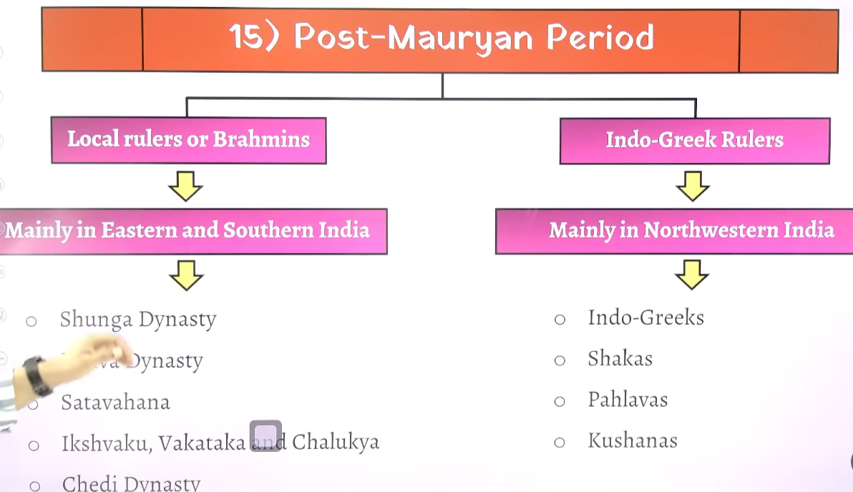

2

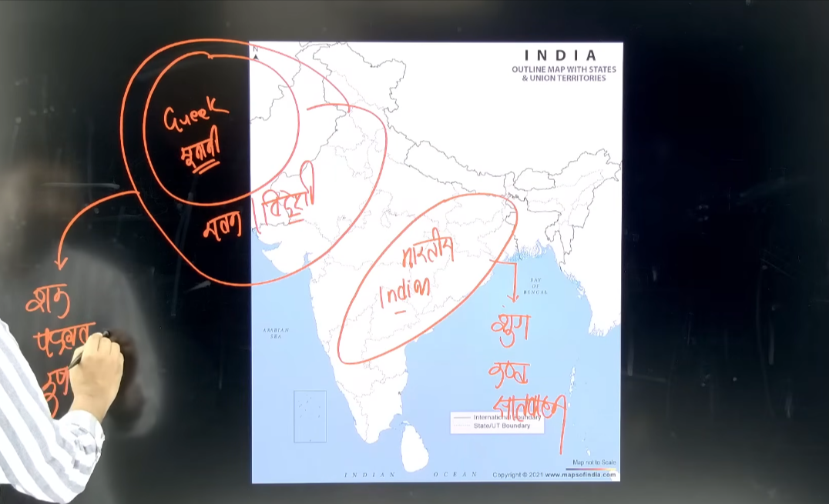

3
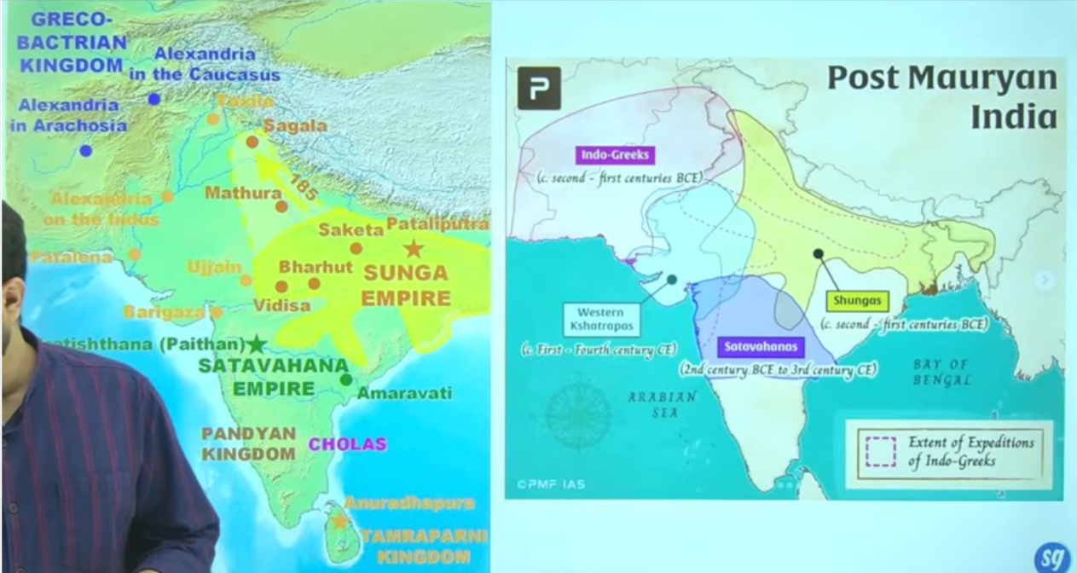

4
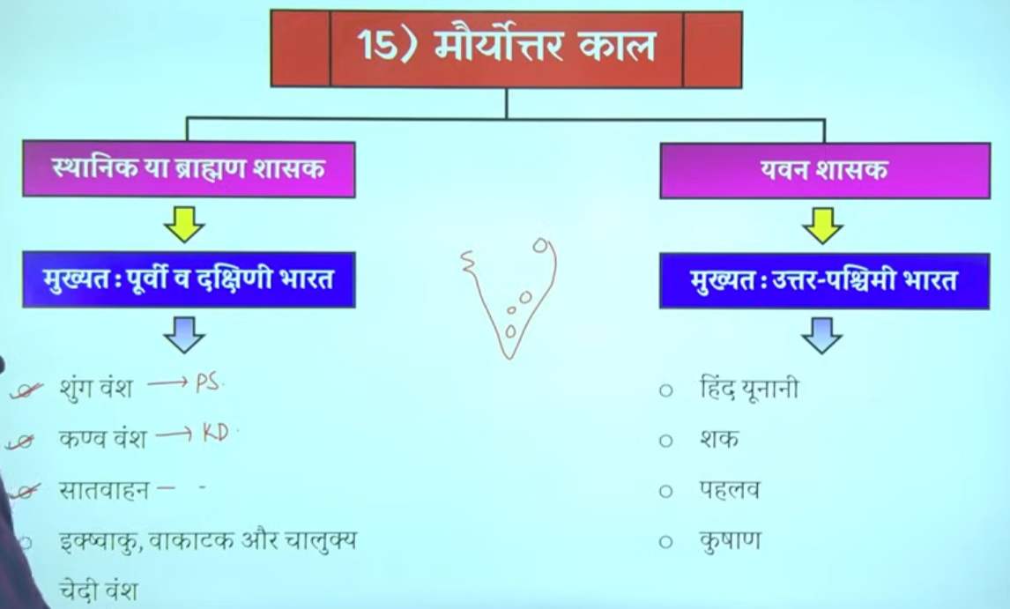

5
भारतीय राज्यों को ब्राह्मण राज्य (Brahmanical States) भी कहा गया है, विशेषकर मौर्योत्तर काल (Post-Mauryan Period) में।
इतिहास में एक सामान्य pattern देखा जाता है:
- शुरुआत में छोटे-छोटे राज्य (small states) बनते हैं।
- फिर कोई शक्तिशाली शासक आता है और इन राज्यों को जोड़कर एक विशाल साम्राज्य (empire) बनाता है।
- उसके बाद उसके उत्तराधिकारी (successors) कमजोर हो जाते हैं।
- परिणामस्वरूप, वह बड़ा साम्राज्य फिर से छोटे-छोटे राज्यों में टूट जाता है।
👉 इसी कारण एक समय पर कई अलग-अलग राज्य और वंश (dynasties) एक साथ दिखाई देते हैं।

🔁 भारतीय इतिहास में यह चक्र (Cycle)
- मौर्य साम्राज्य के बाद → छोटे-छोटे राज्य
- फिर गुप्त साम्राज्य आया → पुनः एकीकरण
- गुप्तों के पतन के बाद → फिर विखंडन
- फिर दिल्ली सल्तनत → पुनः एकीकरण
- उसके बाद विघटन
- फिर मुगल साम्राज्य → फिर से एकीकरण
- मुगलों के पतन के बाद → पुनः छोटे राज्य

🇮🇳 वर्तमान स्थिति
आज भारत में यह स्थिति नहीं है क्योंकि:
- हम एक लोकतांत्रिक (Democratic)
- और गणतांत्रिक (Republic) देश हैं
👉 इसलिए अब देश एकजुट (united) रहता है।

🔥 One Line (Exam Ready):
भारतीय इतिहास में बार-बार एकीकरण और विखंडन (unification & fragmentation) का चक्र देखने को मिलता है।

6
🏛️ मौर्योत्तर काल (Post-Mauryan Period)
मौर्य साम्राज्य के पतन के बाद शासकों को दो भागों में बांटकर पढ़ा जाता है:
1️⃣ स्वदेशी (Indigenous) शासक
- भारतीय मूल के राजा indegenious king
- मुख्यतः पूर्वी और दक्षिणी भारत में शासन
- उदाहरण: सातवाहन (Satavahana)
2️⃣ विदेशी (Indo-Greek आदि) शासक
- विदेशी मूल के शासक
- मुख्यतः उत्तर-पश्चिम भारत में शासन
- उदाहरण: इंडो-ग्रीक

👑 सातवाहन वंश (Satavahana Dynasty)
- सातवाहनों ने लगभग 300–400 वर्षों तक शासन किया
- यह प्राचीन भारत का सबसे लंबे समय तक शासन करने वाला वंशों में से एक था
👉 तुलना:
- मौर्य वंश ने लगभग 200–250 वर्षों तक शासन किया
- इसलिए सातवाहनों का शासन अधिक लंबा माना जाता है
मौर्योत्तर काल में शासकों को स्वदेशी और विदेशी में बांटा जाता है, जिनमें सातवाहन सबसे लंबे समय तक शासन करने वाले वंशों में से एक थे।

7
Sathvahan ne 300-400 salo tk shaahsn kyia tha ye aisa pahla rajvansha tha jisne itne lambe samya tka shashan kyia tha mauryaon ne bhe itna lamba shashan nahi kyia tha unhion 200-250 varsh tk he sshashan kyia tha

Bharat me ke post Mauryan time per east south me bhartyia mul ke rajah shashan kar rahe the to isse samay per paralleel north -west inda me indo Greek ruler rule kar rahe the
Sahaka are cythina isme jo shaka hai inhone bharat me 5 alag alag shakhao me shashan kyia tha jinhe chatrap kahah jat ahai
Bharat me shtrap pradali ko lane ka Shreya persian ko dyia jata ahi vishes taur per daraius first ko but shako ne usko bade paimaine per use kyia tha
Bhata me Mauryan kaal ka jb patan hua tha bharat ka sabse bada samrajya bhart ke chote chote samrajyo frangment state me bhatt gyaya tha

Where as the central and north west of india ruled by Greek ruler sucha as indo Greek cythian, parthiyan kushans
Whae Madhya aur uttar prachicm bharat me unanan ya Greek ruler ne shahsan kyia tha

Shunga ke captioa the patliputra nad vidhisha

Sathvahan ke ek capital prathesthan aur dusre Amravati the
Shaka 5 alag alag shakao me bharat me the to unko strhrap bola gaya hai

8

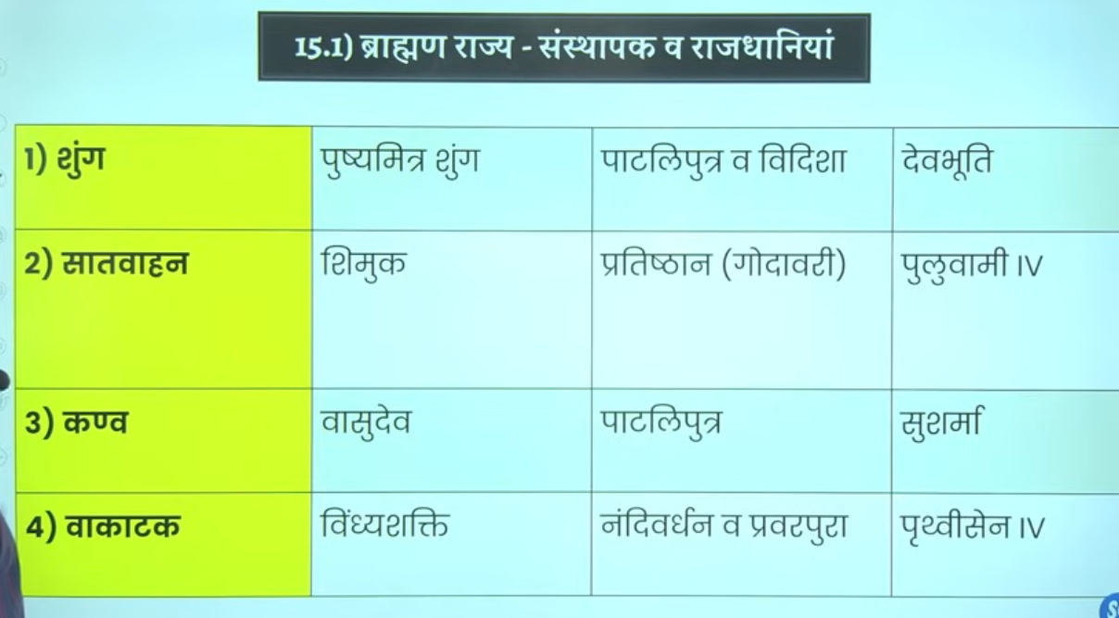

Shunga dynasty me ke do he mahahn shashak hue hai Shunga dynasty magadh and mp wale region me rule kar rahe the

Ek to pushmitra shung jfounder
And dusra agnimitra
Isley famous hue kuki mahavkavi kalidas ne ek natak likha malivakimitra jisme Malvika aur agnimtria ke kahani ko vistar se discuss kyia tgaya hia

Post maury KE BAAD jitne bhe ruler ingeginous ruler aye inhone vedic dharma ka palan kyia hai ye sabhe vedic dharma ke follower the iska matlab ye nahi hai ki inhone dusre dhamr ka samaan nahi kyai
Isley is kaal ko brahman rajya bhe kaha jata ahi aur ye wo kaal hai jisme ye dobara se vedic dharma ko punaristhapti karenge ye vedic regliigon ko ek parakar se fir se reinvednte karenge india me vedic relgion ke buraee ko door karte hue jb rking is dhamko kao apnayega to praja bhe in dharam se jood jayege to yahe karan hai inhe brahman rajya bhe kahah jata hai

Shunga ko Padini ne inhie Bhardwaj gotra ka brahman batya kalidas ne Kashyap gota ka inke ancestor mp ujjan ke the

9 Shunga Dynasty Shunga Dynasty: Ruled for about 112 years (c. 185 BCE – 73 BCE) 2 BCE-1 BCE
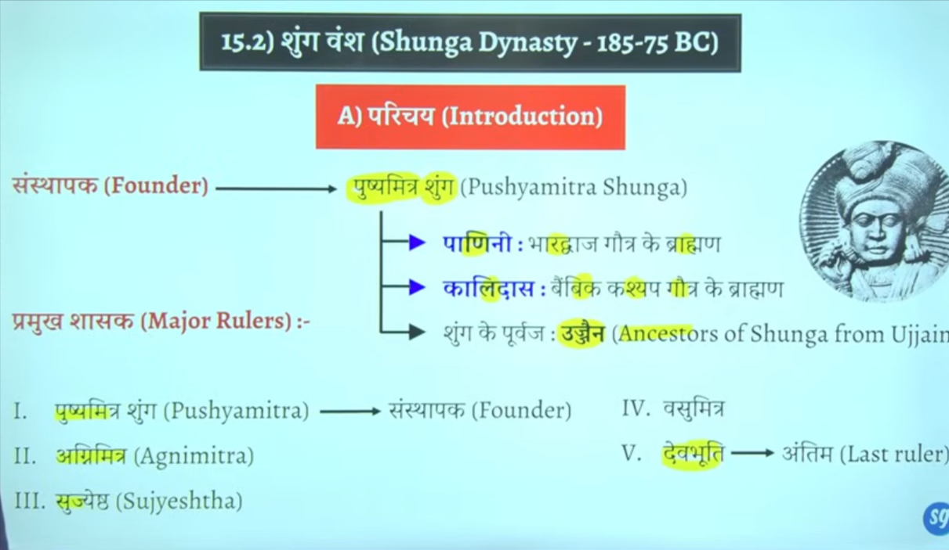

Inke Rajdhani patliputra veidhisa
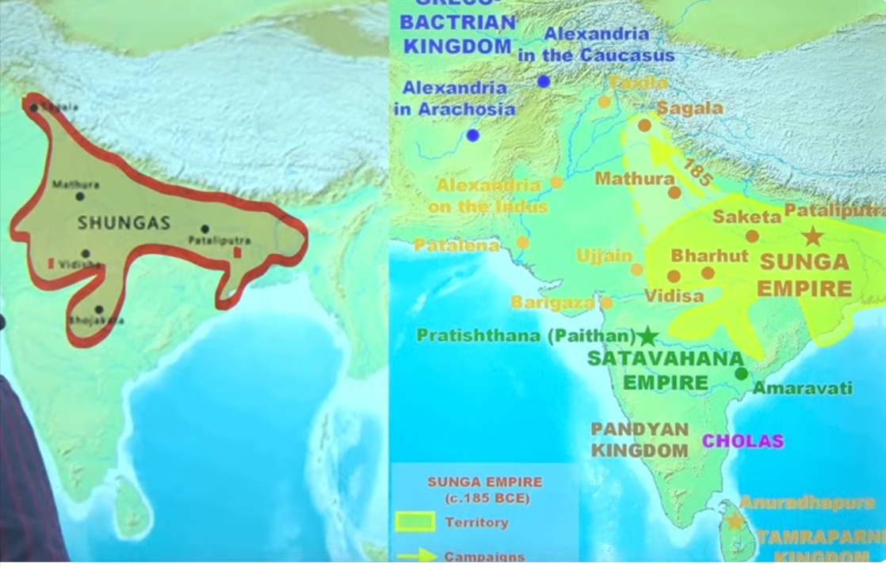

10 Pushyamitra shunga
Na sir shungo ne balki sathvahhano ne bhe isee tarah ke title upadhi ka proyog kyai tha jayega kuki ye sabhe vedic dharm brahman dharm ko matne the inke shashan kaal me inhone pure koshisk ke hai ke vedic dhamr ke punas ishtapana kar de jaye

Even you can see tha t pushyamitra shung ke purohit ka naam Patanjali tha
Ptanjali jinhone astadhayee per mahabhays ke rachna ke hai inke purohit ptanjali ne inse do bar ashwamedh yugyaa karwaas ytha
Ashwvmedh yaygay ko yagyo ka rajaj kahah jata hai ye sabse abadda yagya tha jo rajnatiek vistar aur samprabhuta ko dekhata tha jo political expansion and sovernity ko dekhata tha ek horse jaha jahah jjata wo sara Chetra us rajya ke antargat aa jata tha is yagaya ke baad samnyata wo raja Chakravarti samrat ke naam se jana jat a tha
Ye yaad Rakha ke hau ku ise vedic purnarjagran ka kaal bol rahe hai

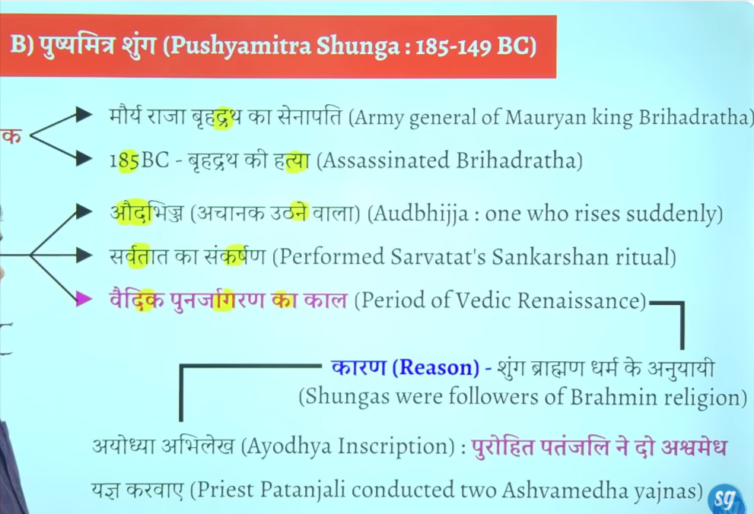

Ye wahe menander hai jisne nagsen ke ssath ek vad vivad pratiyoga ke the phir unke question answer pe ek book likhe kage the milindpanho ye wahe menander Milind hai
Book name minlindapahno Milind ke question
Sanchi ke stoop ke railing mitti kie bane the isne usko stone ka bnwaw tha
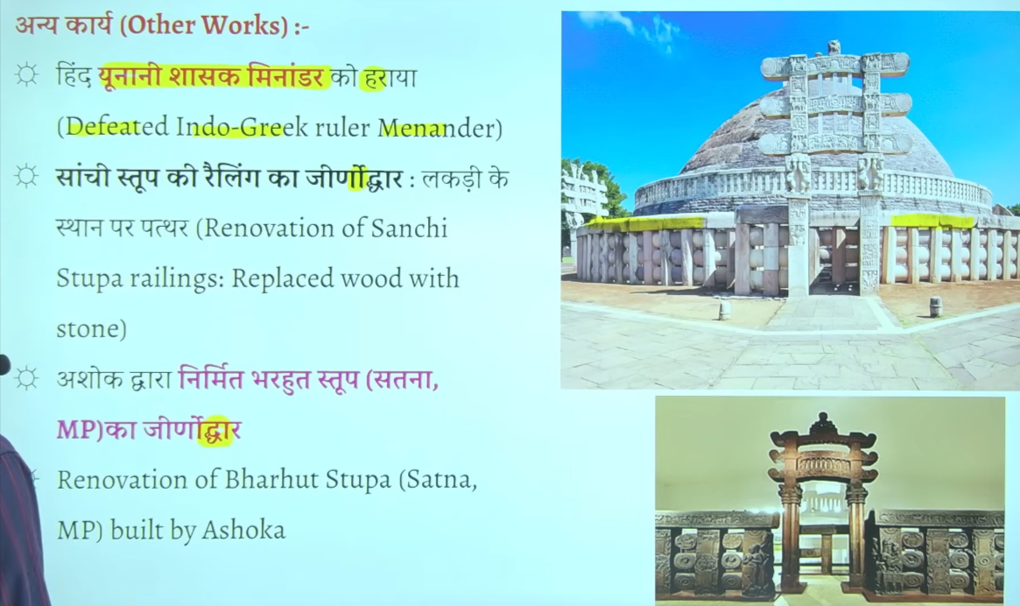
📚 Shunga Dynasty – UPSC Important Points

📅 Time Period
- c. 185 BCE – 73 BCE
- Founded after the fall of Mauryan Empire

👑 Founder
- Pushyamitra Shunga
- Was a Brahmin general of the Mauryas
- Killed last Mauryan ruler Brihadratha Maurya

🏛️ Capital
- Pataliputra (main capital)
- Vidisha (second important center)

⚔️ Political Features
- Faced Yavana (Indo-Greek) invasions
- Successfully defended kingdom
- Empire mainly in North & Central India

🕉️ Religion
- Followed Brahmanism (Vedic religion)
- Performed Ashvamedha Yajna
- Sometimes seen as revival of Brahmanical traditions

🏗️ Art & Architecture
- Development of Buddhist architecture continued
- Important sites:
  - Sanchi Stupa (expanded)
  - Bharhut Stupa

📜 Literature
- Period of Patanjali
- Work: Mahabhashya
- Mentions Yavana invasions

❌ Decline
- Last ruler: Devabhuti
- Killed by minister Vasudeva Kanva
- Led to rise of Kanva Dynasty

⭐ UPSC Important Facts
- Post-Mauryan Brahmanical dynasty
- Known for revival of Vedic practices
- Coexisted with Indo-Greeks

🔥 One Line (Exam Ready):
Shunga Dynasty (185–73 BCE), founded by Pushyamitra, marked Brahmanical revival and resistance to Indo-Greek invasions 👍
agnimtira importnat points

11 Agnimitra

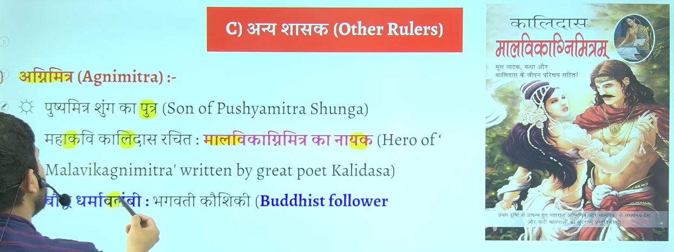
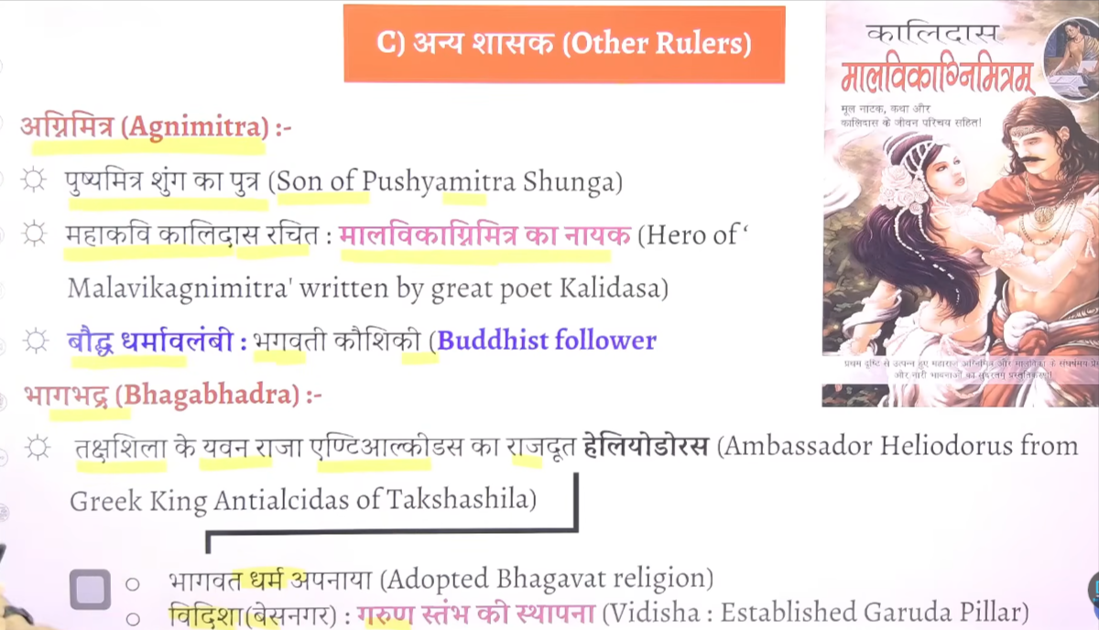

12 Bhagabhadra

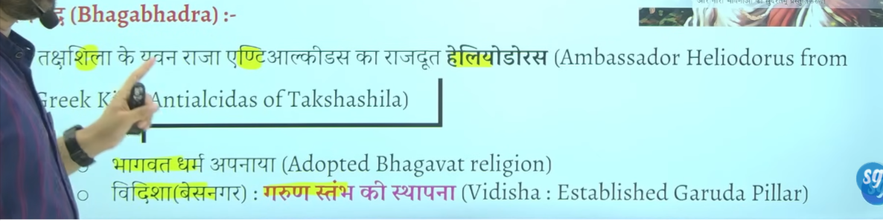

Bhagbhadra ke sahashan kaal me taksheeela ke ingogreek ruler antialciadas ke ambesador heliodoruosu inke shahsan kaal me ayay tha Vidisha ayaa tha
Jo ke bhavgvat dharm se influence hokar bhagvat dharm ko apnaya tha
Vidisha jisee basenagar kaaha jaat ahai inse wahah garin ishtam ko establish kyia tha
📚 Agnimitra – Important Points (UPSC)

👑 Who was he?
- Second ruler of the Shunga Dynasty
- Son of Pushyamitra Shunga

🏛️ Position Before King
- Served as Viceroy (Governor) of Vidisha

⚔️ Political Achievement
- Fought a war with the Vidarbha kingdom
- Successfully established Shunga control over Vidarbha

📖 Literary Reference
- Mentioned in the famous Sanskrit play
👉 Malavikagnimitram by Kalidasa

⭐ Importance
- Shows political expansion of Shungas in Central India
- Known mainly through literary sources rather than inscriptions
Agnimitra, son of Pushyamitra, was the second Shunga ruler, known for the Vidarbha war and mention in Malavikagnimitram 👍

12 devbhuti

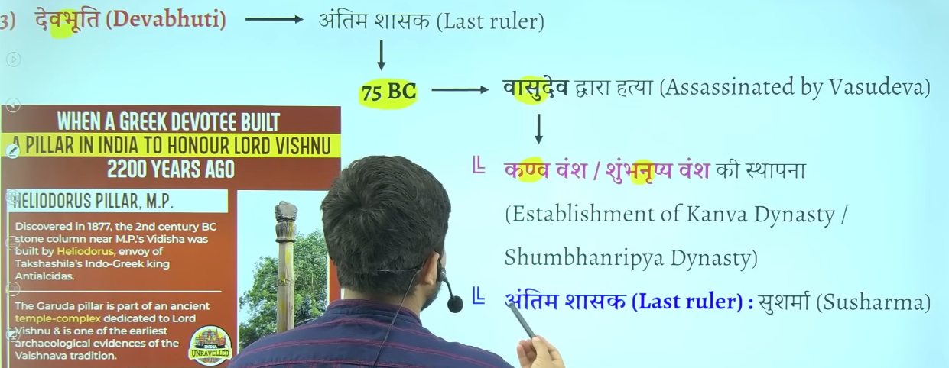

Kanva vansha j 10 20 saal he chaal kanva ka antim ruler shusharma hua jisko marka ke simuk ne sathvahan dynasty establish kyia tha

13 Shunga Dynasty – Rulers (with time)
- ⭐ Pushyamitra Shunga (c. 185–149 BCE)
- ⭐ Agnimitra (c. 149–141 BCE)
- Vasumitra (c. 141–131 BCE)
- Bhadraka (c. 131–124 BCE)
- Pulindaka (c. 124–122 BCE)
- Ghosha (c. 122–114 BCE)
- Vajramitra (c. 114–82 BCE)
- ⭐ Bhagabhadra (c. 82–75 BCE)
- ⭐ Devabhuti (c. 75–73 BCE)

🔥 Important yaad rakho:
👉 ⭐ = Exam me zyada puchhe jaate hain
👉 Start: Pushyamitra
👉 End: Devabhuti

14 Patanjali
👉 Patanjali was an important ancient Indian scholar known for grammar and philosophy.

📅 Time Period
- Around 2nd century BCE
- Generally associated with c. 150 BCE

👑 Dynasty / Ruler
- Belonged to the period of Shunga Dynasty
- Contemporary of Pushyamitra Shunga

📝 Major Work
- Mahabhashya (महाभाष्य)
  - A commentary on Panini’s Ashtadhyayi
  - Important text on Sanskrit grammar

⭐ Importance
- One of the greatest grammarians of ancient India
- Provides historical references of his time
- Mentions events like Yavana (Greek) invasions

❗ Note
- This Patanjali (grammarian) is different from Yoga Patanjali (Yoga Sutra author)

👉 One Line (Exam Ready):
Patanjali (c. 150 BCE), a scholar of the Shunga period, wrote Mahabhashya, a key work on Sanskrit grammar 👍

15
📚 Shunga Dynasty – Sources of Information (UPSC)

📖 1. Literary Sources (साहित्यिक स्रोत)
- Kalidasa’s Malavikagnimitram
👉 Agnimitra और Shunga शासन की जानकारी देता है
- Patanjali – Mahabhashya
👉 Yavana आक्रमण और उस समय की स्थिति का वर्णन
- Puranas (पुराण)
👉 शुंग शासकों की सूची और वंशावली
- Buddhist Texts (Divyavadana)
👉 Pushyamitra के बारे में उल्लेख

🪨 2. Archaeological Sources (पुरातात्त्विक स्रोत)
- Bharhut Stupa inscriptions
👉 Shunga काल की कला और दान की जानकारी
- Sanchi Stupa
👉 Shunga काल में विस्तार और निर्माण कार्य

🪙 3. Numismatic Sources (सिक्के)
- Shunga काल के coins (सिक्के)
👉 शासकों और आर्थिक स्थिति की जानकारी

🔥 One Line (Exam Ready):
Shunga Dynasty के स्रोत हैं literary (Malavikagnimitram, Mahabhashya, Puranas), archaeological (Sanchi, Bharhut), और coins 👍
📚 Shunga Dynasty का उल्लेख किन पुराणों में है?
👉 शुंग वंश का उल्लेख कई पुराणों में मिलता है, जैसे:
- Vayu Purana
- Matsya Purana
- Brahmanda Purana
- Vishnu Purana
👉 इनमें शुंग शासकों की वंशावली (genealogy) और शासन का विवरण मिलता है

❓ Patanjali के Mahabhashya में Shunga का उल्लेख कैसे?
👉 सही है कि Patanjali का Mahabhashya मुख्यतः संस्कृत व्याकरण पर है
👉 लेकिन ध्यान दो 👇
- उस समय के उदाहरण (examples) देने के लिए
- Patanjali ने समकालीन घटनाओं (current events) का उपयोग किया
👉 जैसे:
- यवन (Indo-Greek) आक्रमण का उल्लेख
- उस समय की राजनीतिक स्थिति
👉 इसलिए indirectly हमें Shunga period की जानकारी मिलती है

🔥 Easy समझो (1 लाइन में):
- Purana → Direct info (वंश और राजा)
- Mahabhashya → Indirect info (समकालीन घटनाएँ)

👉 Final One Line (UPSC):
Shunga Dynasty is mentioned in Puranas directly, while Patanjali’s Mahabhashya gives indirect historical references through contemporary examples 👍

Shunga dynasty

Ye gairchetryia shashak tha jati se brahman tha budha dharma ko sabse adhik nuksan pushyamitra shunga ne karway tha
Capital of shunga wans is vidhisa or patiliputra but main is mp me vidhisa ye patliputra se Rajdhani udhakar le gaya madhyapradesh kke vidhisa me
Ye buddha virohdi tha isme bahut sare buddha stupo ko nast karwa dyia tha but isne sanchi and barhut sitop ka punarnirman bhe Karwar tha

Usne bahut sare buddha stop ko tokar waha Sanskrit vidyaaly , mandir, ya gurukul jo use dekh laga usne wo banwaya tha jaha uskno nast karna thek laga usne nast karwa tha
Patanjali pushyamitra ke purohit the yani inke yaah jo bhe puja path hoga wo Patanjali karte the
Iske time per bahut sare granth likhe gae hai tojada tar granth pushyamitra ke time per he likhe gae hthe
Isne bahtu sare buddha vihar ka Nirman bhe karawa aur nast bhe kyai tha but jaydatar nast kyia tha
Ikse time per he buddhsit book jatak ka Nirman purja hua tha iske time per he Sanskrit book astadyaye ka Nirman hua tha iske timer per he manuistmiti likhe gae the

Astadyaee kisse sambhandit hai vyakarna se sambahndieth hai
Ye teeno pramukh book iske time per he likhe gae the

Gargi ne likha tha gargisamhita budah bikshuk ne likha jatak granth

Manusmirit bahut controversial book tha usme women and dalit ko uchit ishtan nahi dyai gaya hai

Jinsen ne harivasnh ke rachna ke to sabse Jayda book kiske tim per likhe gae to answer is pushymitr ashunga

Jb pushymitra shunga shanshn kar rahah tha tb magadh samrajya ka ant ho chuka tha cuki magadhsamrajya bahut he saktishali smarjay tha Ashoka bahut shaktishali tha uske succesoer bahtu weak the iska news agala bhagal ke Chetra me fail gayay tha jiske karan jo central asia and north west area ke indo Greek vedeshi rulers the unhone socha ke ku na magad per akraman kar de kuki magadh samrjaya to khtm ho chuka hai to fir Videsh se akraman hona fir se chalu ho gaya tha halaki apapa dehskte hai jb tk Mauryan dynasty the tb tk koi vedsehi akrmankari nahi ayaya tha
Chuki pushymitra shung ne bradhrth ko mara iske news pure bharat aur bharah bhe fail gae the to viedshi akrmankariyon ne socha ku na hum jakar pushymitra shung ko mar de

Pushymtir shung ke samay do vedhsie akramankari aye cuki wo madya asia central asia se aee the to unko yavan kahah jata tha
To pushmmitra suhung ke samay kitne akrman hue to do dono akraman yavan ne kyia tha aur pushyamitr ashunga ne dono ko hara dyia tha

Jaise isne harya iska varchasva bad gyay logo ne baola are bhaut shaktishali kiukisisne do vedehsi yvana akramankari ko parajeet kar dyai agal bagal me pushmita shung ke naam ka dahshat fail gaya tha
Pushmitra shung ne socha acha mauka hai patanjiali ko bulakar do ashvamedh yagay kar dyai
Chuki jb yavan akramankair ko harya tha to bharat ka chote mote raja aise he dar gaey the t o iske ashwamedh yagya ka horse ko chedna kisne ne ucht nahi samjha tha
Jitne bhar isne vedhesh ko harya utne baar isne aswmedh yagya karwaya tha
Do bar vedshi akrmankair aye aur dono bar shunga jeeta do aswamedh ygay karawa dono ke purohit the ptanjali

Pushyamitr ashung jeta tha apne beta ke wajah se iska bet atha agnimitra jo bhaut yogya tha yudh karke laut rahah tha aur ye fas gaya ek mahila ek prem me Malvika naam ke mahila the

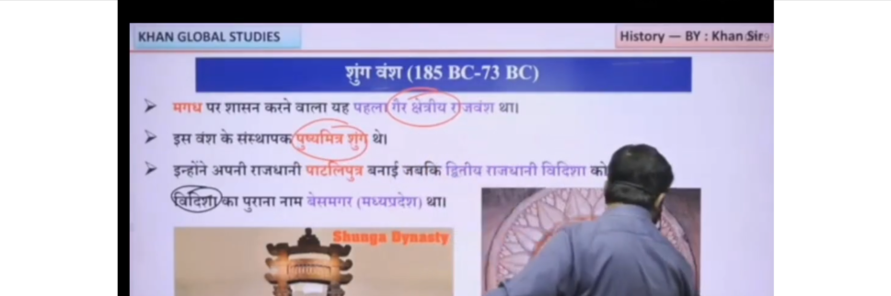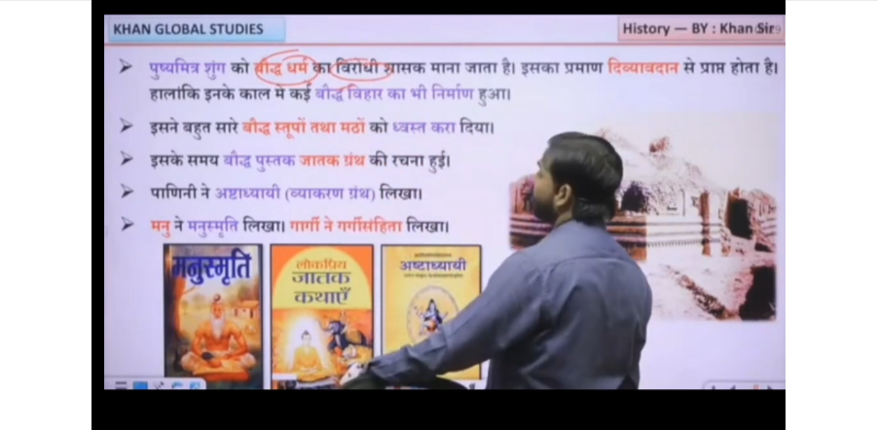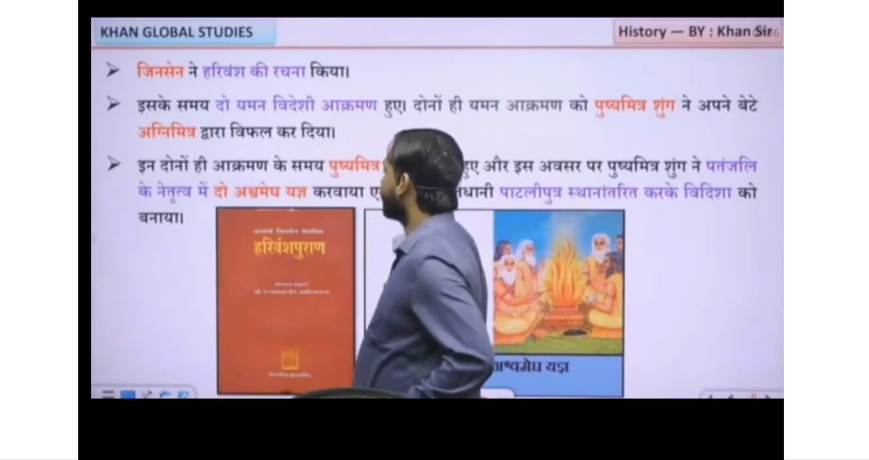

When the Shunga dynasty ruled Magadha (c. 185–73 BCE) after the fall of the Mauryas, India was politically fragmented and many regional dynasties and tribal powers ruled different parts of the subcontinent independently.
In the North-West, Indo-Greek rulers (like Menander later) controlled parts of Punjab and Gandhara, while Central Asian influence was increasing. In the North (other regions of Gangetic plains), several smaller republican or monarchical states existed, including remnants of old Mahajanapadas like Kuru-Panchala areas under local rulers. In the West India, regions like Malwa and Gujarat saw the rise of early local powers and Indo-Greek/Indo-Scythian influences later, with growing trade-based urban centers. In the South, powerful regional dynasties like the Satavahanas (Deccan region) emerged and expanded, controlling trade routes and acting as a major political force. Meanwhile, in the East (Kalinga/Odisha), the Mahameghavahana Chedi dynasty under Kharavela became prominent, restoring Kalinga’s power and expanding its influence.
Thus, during the Shunga period in Magadha, India was not unified but divided into multiple regional kingdoms and emerging dynasties, marking a strong phase of regionalization after Mauryan imperial decline.

